Full Stack Development with MERN
Project Documentation

1. Introduction
Project Title: OrderOnTheGo
Team Members:
- Varupula Roja (23481A05P2) : (Team Leader) Backend Development, Schemas & Controllers
- Vakada Srinu (22481A05O0): Backend Development, Rotes & API Integration
- Valluri Saranya (22481A12H5): Frontend Development, UI Design & Implementation
- Vallabhaneni Rishitha Chowdary (24485A0524): Frontend Development, Authentication, Cart & Order Logic

2. Project Overview
Purpose
OrderOnTheGo is a food ordering platform built with the MERN stack. The goal is to connect users with local restaurants through an easy-to-use, secure platform that allows browsing, ordering, and managing orders. Restaurant owners can manage their menu, and admins can promote restaurants and oversee the platform's operation.
Features
- User authentication (sign up, login, JWT token)
- Browse restaurants, products, and categories
- Cart management (add/remove items)
- Order placement and tracking
- Restaurant management (add, update, delete products)
- Admin dashboard for restaurant promotions

3. Architecture
Frontend
The frontend is built using React.js. It includes:
- React Router for dynamic page routing.
- Redux (optional) for state management.
- Custom components for user interface design, including reusable components like the header, footer, cart, and product cards.
Backend
The backend uses Node.js and Express.js to handle:
- API routes for user authentication, cart management, and order processing.
- Role-based access control (user, restaurant, admin).
- JWT token authentication for secure communication.
Database
The database uses MongoDB for storing:
- Users (authentication data)
- Restaurants (details, products, orders)
- Orders (order status, payment tracking)

4. Setup Instructions
Prerequisites
- Node.js: Version 14.x or higher
- MongoDB: Installed locally or using MongoDB Atlas
- npm: Node package manager
Installation
- Clone the repository:
git clone https://github.com/your-repo/OrderOnTheGo.git
- Install Dependencies:
  - For Frontend (React):
  - cd client
  - npm install
  - For Backend (Node.js, Express):
  - cd server
  - npm install
- Set up environment variables:
  - Create .env files in both client and server directories:
    - Frontend: Set the API base URL (REACT_APP_API_URL)
    - Backend: Set MongoDB URI (MONGO_URI), JWT secret (JWT_SECRET)
- Start the Application:
  - For Frontend:
  - cd client
  - npm start
  - For Backend:
  - cd server
  - npm start

5. Folder Structure
Client
- client/: React.js frontend folder.
  - src/
    - components/: Reusable UI components (e.g., Header, Footer)
    - pages/: React components for different routes (e.g., Home, Cart, Orders)
    - redux/: Optional state management files (if Redux is used)
Server
- server/: Node.js backend folder.
  - controllers/: Logic to handle API requests.
  - models/: MongoDB schema models.
  - routes/: API routes (e.g., user, restaurant, order).
  - middleware/: Custom middleware (e.g., authentication, error handling).
  - config/: Environment variables and database connection.

6. Running the Application
To start the application locally, follow these commands:
- Frontend:
- cd client
- npm start
- Backend:
- cd server
- npm start

7. API Documentation
User Endpoints
- POST /api /register: Register a new user
- POST /api /login: Log in and receive JWT token
- GET /api /profile: Get user details (Protected route)
Restaurant Endpoints
- POST /api/restaurants/login: Restaurant login
- GET /api/restaurants/:id/products: Get products for a specific restaurant
- POST /api/restaurants/:id/products: Add a product
Order Endpoints
- POST /api/orders: Create a new order
- GET /api/orders/:id: Get order details
Admin Endpoints
- POST /api/admin/promote/:id: Promote restaurant to homepage

8. Authentication
Authentication in OrderOnTheGo is handled using bcrypt for secure password hashing and React Context API for client-side authentication state management.
- Password Handling:
  - User passwords are hashed using bcrypt before being stored in the database.
  - During login, the hashed password is compared with the entered password securely.
- Session Management:
  - Once a user logs in, their information (like user ID, role, etc.) is stored in React’s Auth Context.
  - This context is used across the app to control access to protected routes and display appropriate UI components (e.g., user vs. restaurant header).
- Role-Based Access:
  - React Context tracks user roles (user, restaurant, admin) to ensure each role sees the correct dashboard and has access to relevant features.

9. User Interface
Screenshots showcasing key UI elements:
- Homepage: Displays restaurant categories and popular restaurants.
- Cart Page: Lists added items with the option to update and checkout.
- Restaurant Dashboard: Allows restaurant owners to manage their products.

10. Testing
Testing Strategy
- Unit Tests: Tests for backend API routes, models, and controllers.
- Integration Tests: Full-stack testing (frontend to backend communication).
- Manual Testing: Functional testing of user flows such as login, cart updates, and order placement.
Tools Used
- Jest for unit testing
- Supertest for API testing

11. Screenshots
- Screenshots:
Homepage:
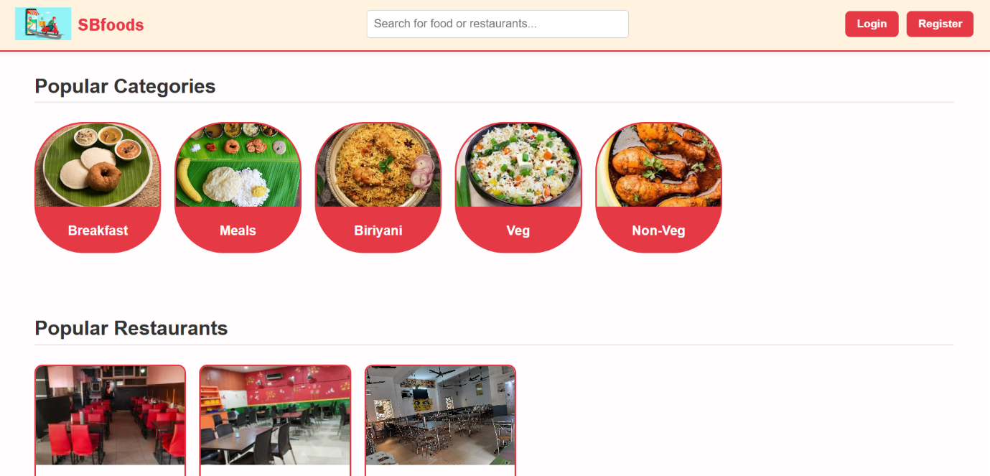
Restaurants:
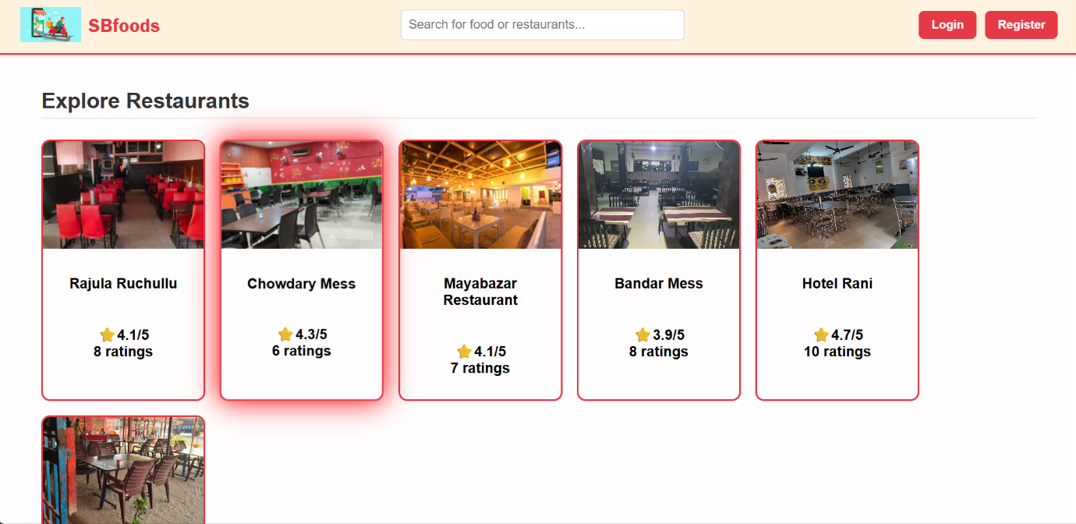
Cart:
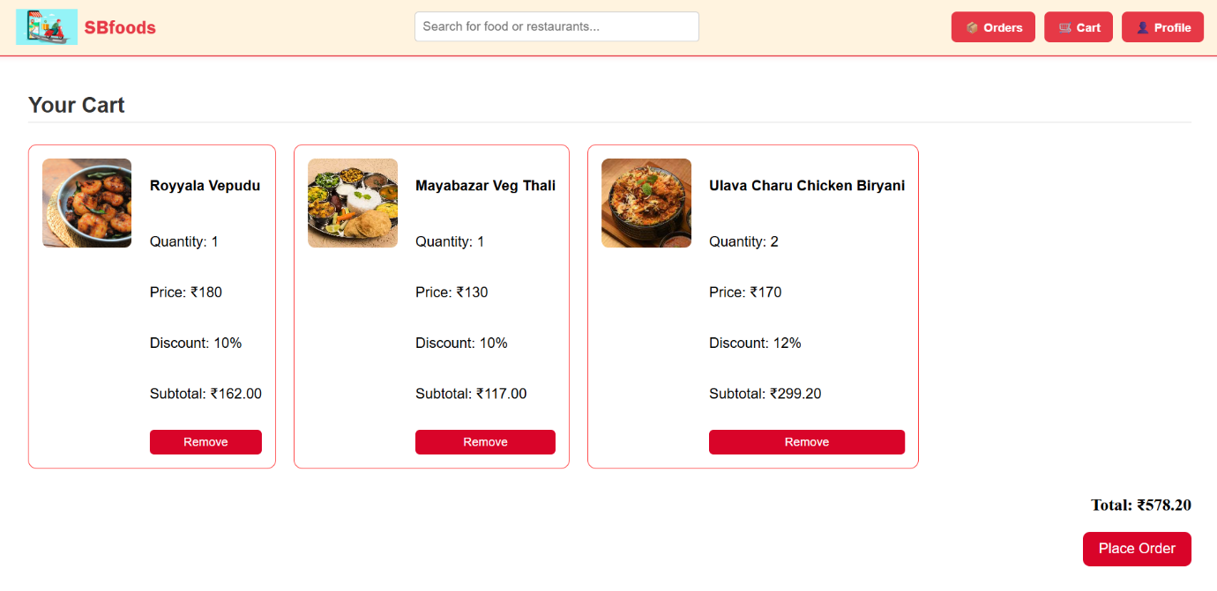
Orders:
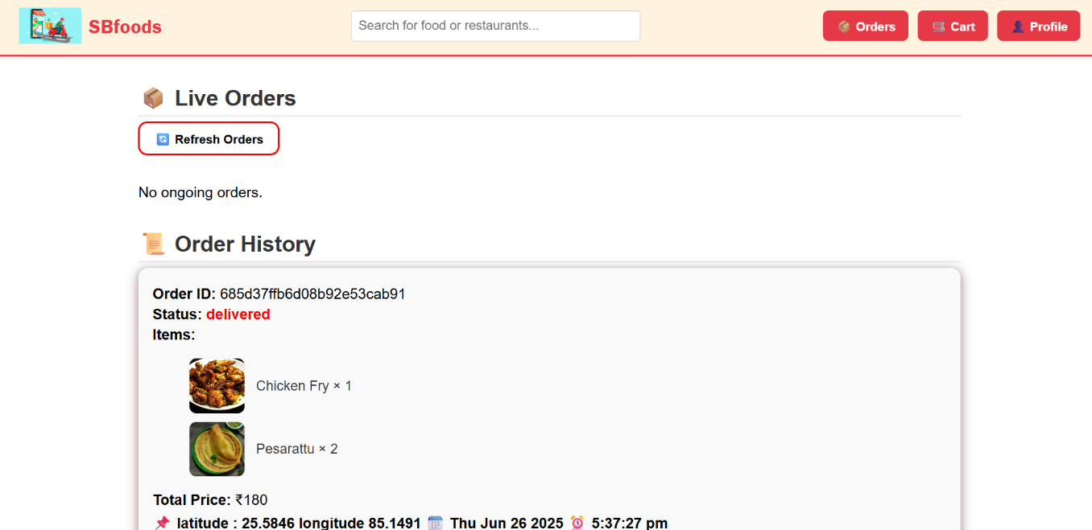
Restaurant Dashboard:
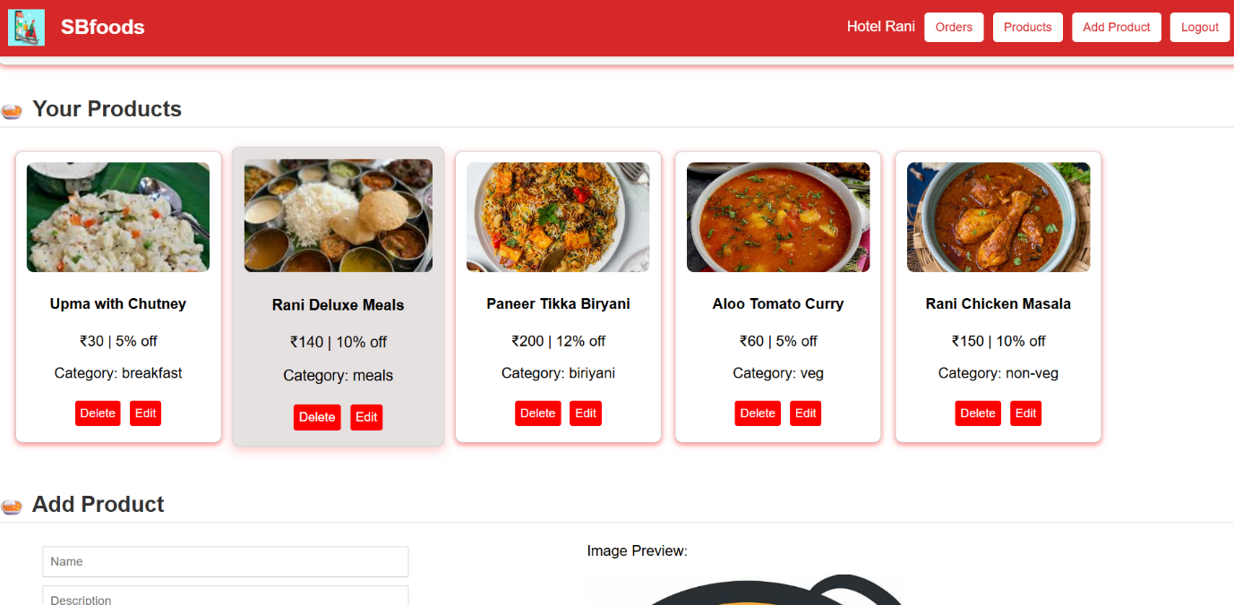
Admin Dashboard:
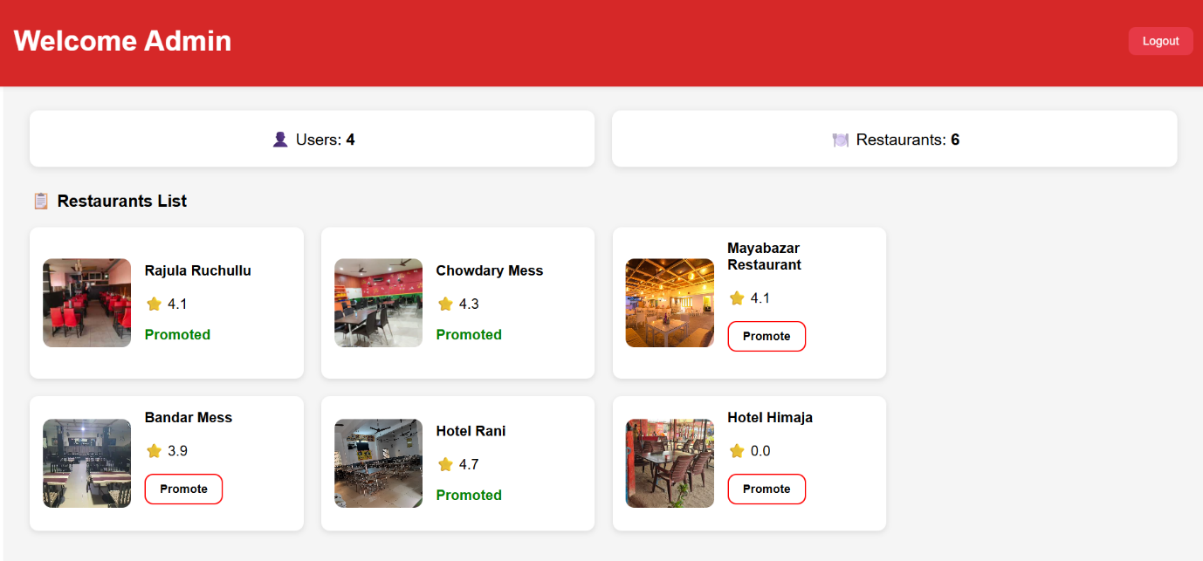

12. Known Issues
- Payment Integration: Not implemented yet, placeholder functionality.
- Mobile App: Currently no mobile app version, only web-based.

13. Future Enhancements
- Payment Gateway: Integrate with a real payment provider (e.g., Stripe, Razorpay).
- Mobile App: Develop a mobile version using React Native.
- Notifications: Implement order status notifications for users and restaurants.
- Analytics Dashboard: Add real-time analytics for restaurants and admins.

